## *POWER BI DOCUMENTATION*

Population :- 2020 - 2019

### Step 1 – Import Data Into Power Bi

Open the get data window

**Instruction:** Go to **Home → Get Data → Excel/CSV → Select the file and click Load**.

**Purpose:** Connect Power BI to the raw dataset stored in a file.

**Effect:** Imports the data into Power Query Editor for transformation.

**Source:** File path or folder location.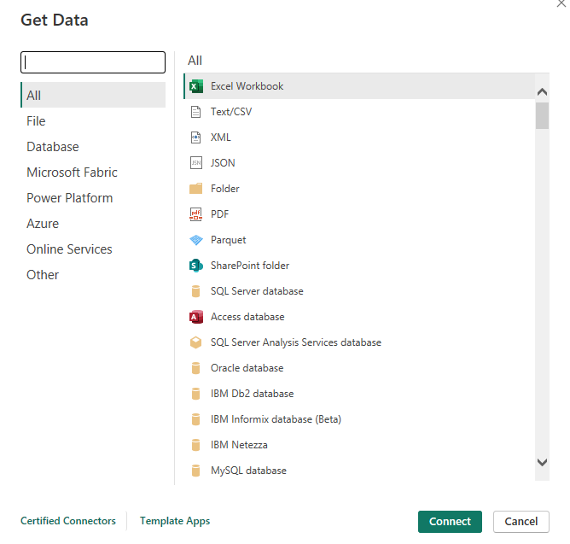

### Step 2 – Promote Headers

**Instruction:** Go to **Home → Use First Row as Headers**.  
**Purpose:** Convert the first row of data into column headers.  
**Effect:** Replaces generic names (Column1, Column2, etc.) with meaningful titles.  
**Source:** Raw file after loading.

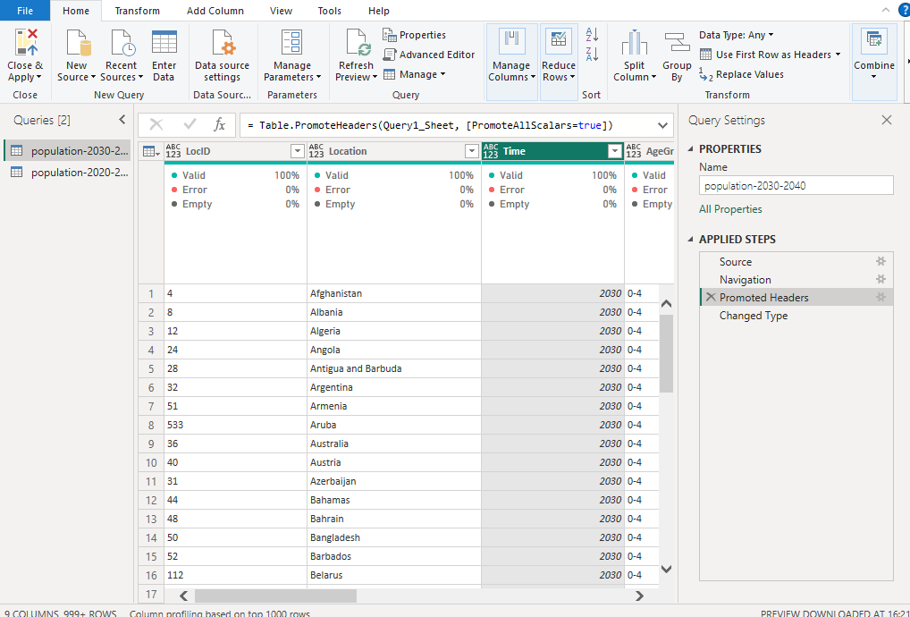

### 

### 

### 

### 

### 

### Step 3 – Trim Text

**Instruction:** Select the required text columns → Go to **Transform → Format → Trim**.  
 **Purpose:** Remove unwanted spaces before/after text values.  
 **Effect:** Prevents mismatches during joins, filters, or grouping.  
 **Source:** Applied after setting headers.

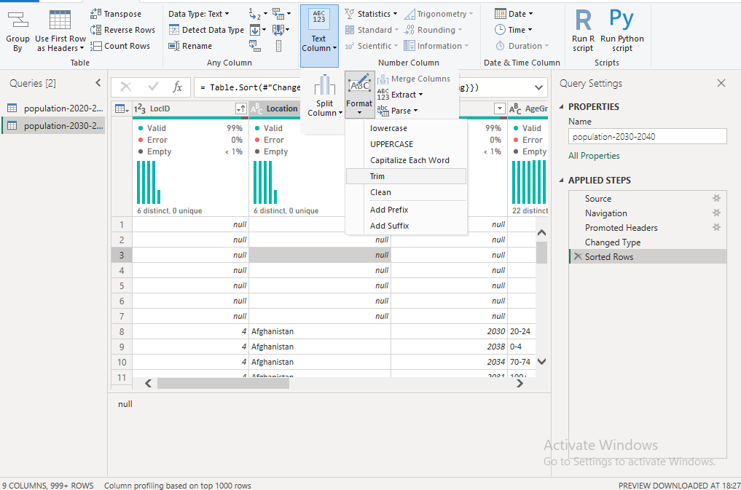

### 

### 

### 

### 

### 

### 

### Step 4 – Filter Rows

**Instruction:** Select the column you want to filter → Click **Filter icon** → Choose/Unchoose values as required.  
 **Purpose:** Keep only relevant data and remove unwanted rows.  
 **Effect:** Reduces dataset size and keeps only valid records.  
 **Source:** Based on column values.

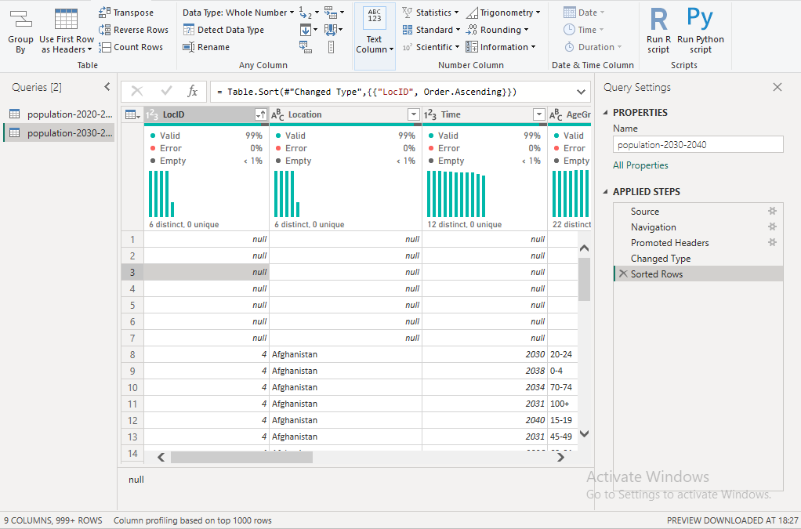

### 

### 

### 

### 

### 

### 

### Step 5 – Change Type

**Instruction:** Select a column → Go to **Home → Data Type** → Choose the correct type (Text, Whole Number, Decimal Number, Date, etc.).  
 **Purpose:** Assign correct data types for proper calculations and visualizations.  
 **Effect:** Prevents errors in formulas, aggregations, and time-based analysis.  
 **Source:** Auto-detected types, manual corrections needed.

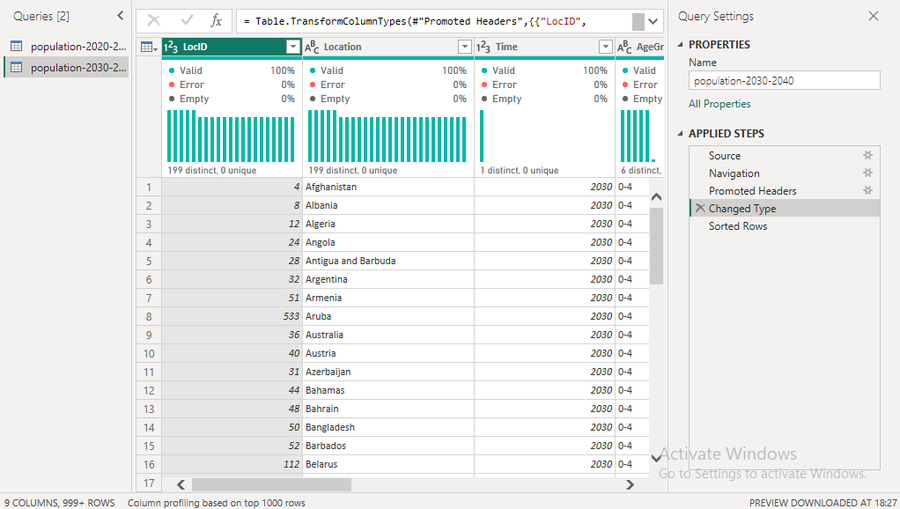

### 

### 

### 

### 

### 

### 

### 

### Step 6 – Rename Columns

**Instruction:** Double-click on the column header → Type the new meaningful name.  
 **Purpose:** Rename columns for clarity and better understanding.  
 **Effect:** Makes the dataset user-friendly and easier to read.  
 **Source:** After promoting headers.

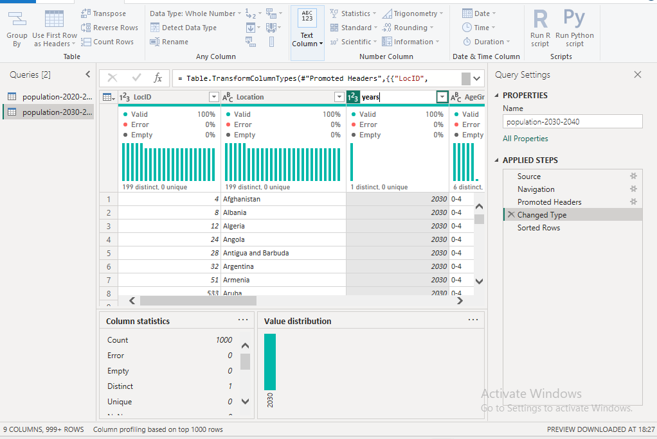

### 

### 

### Step 7 – Replace Value

**Instruction:** Select a column → Go to **Transform → Replace Values** → Enter Old Value and New Value → Click OK.  
 **Purpose:** Replace incorrect or inconsistent data values.  
 **Effect:** Standardizes data (e.g., "N/A" → null, "M" → "Male").  
 **Source:** Manual rule-based cleaning.

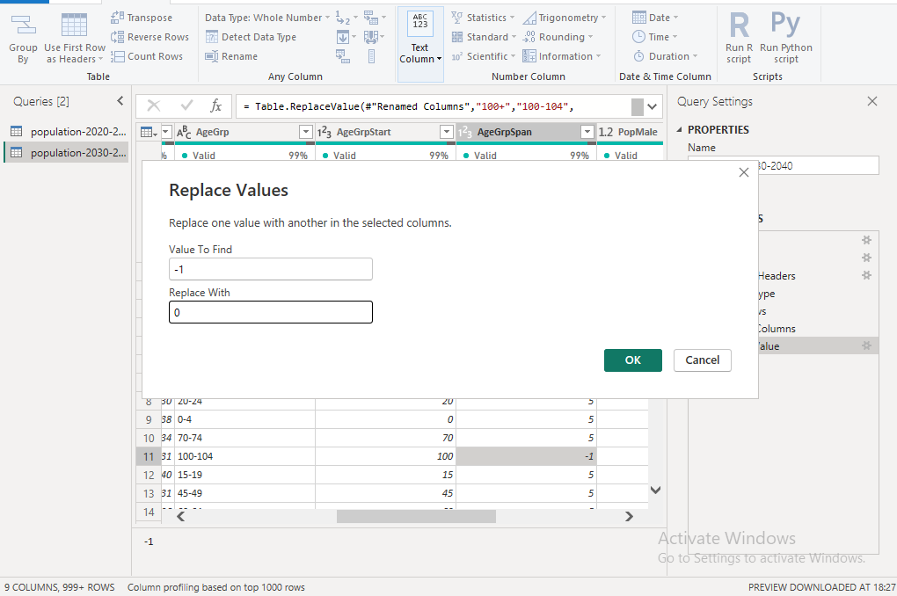

### 

### 

### Step 8 – Replace Value1

**Instruction:** Repeat the **Replace Values** step for another column or additional corrections.  
 **Purpose:** Handle multiple value replacements in different columns.  
 **Effect:** Further cleans and standardizes the dataset.  
 **Source:** Manual cleaning requirement.

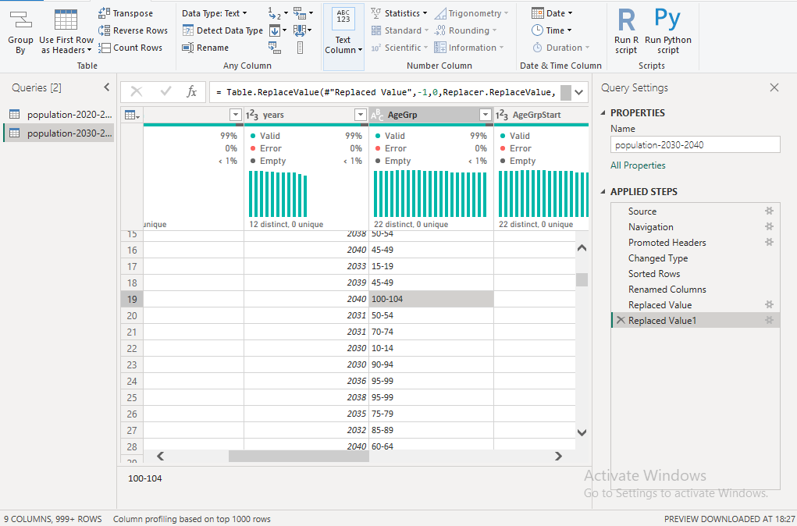

### 

### 

### 

### 

### 

### 

### Step 9 – Changed Type1

**Instruction:** Select the updated column → Go to **Home → Data Type** → Choose the correct type again.  
 **Purpose:** Ensure replaced values are in the correct format.  
 **Effect:** Prevents calculation or filter errors after replacements.  
 **Source:** Applied after replacements.

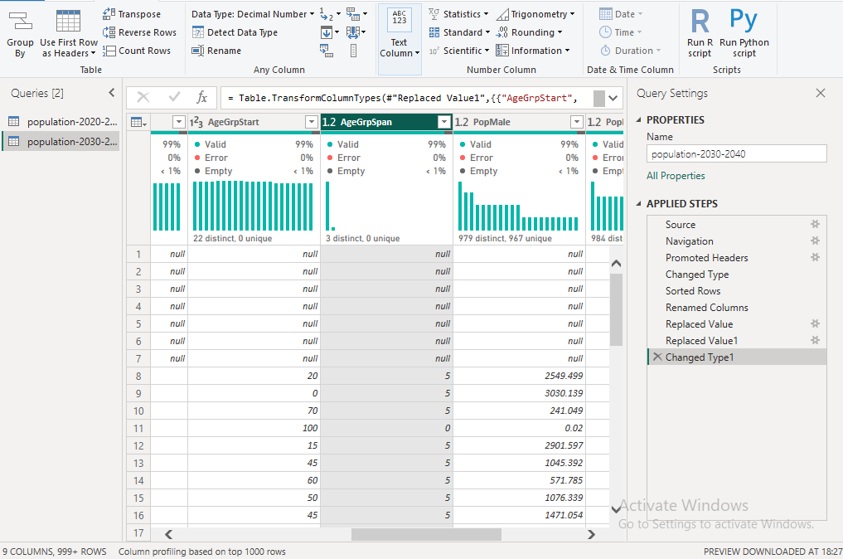

### 

### 

### 

### 

### 

### Step 10 – Filter Rows

**Instruction:** Select the column you want to filter → Click **Filter icon** → Choose/Unchoose values as required.  
 **Purpose:** Keep only relevant data and remove unwanted rows.  
 **Effect:** Reduces dataset size and keeps only valid records.  
 **Source:** Based on column values.

